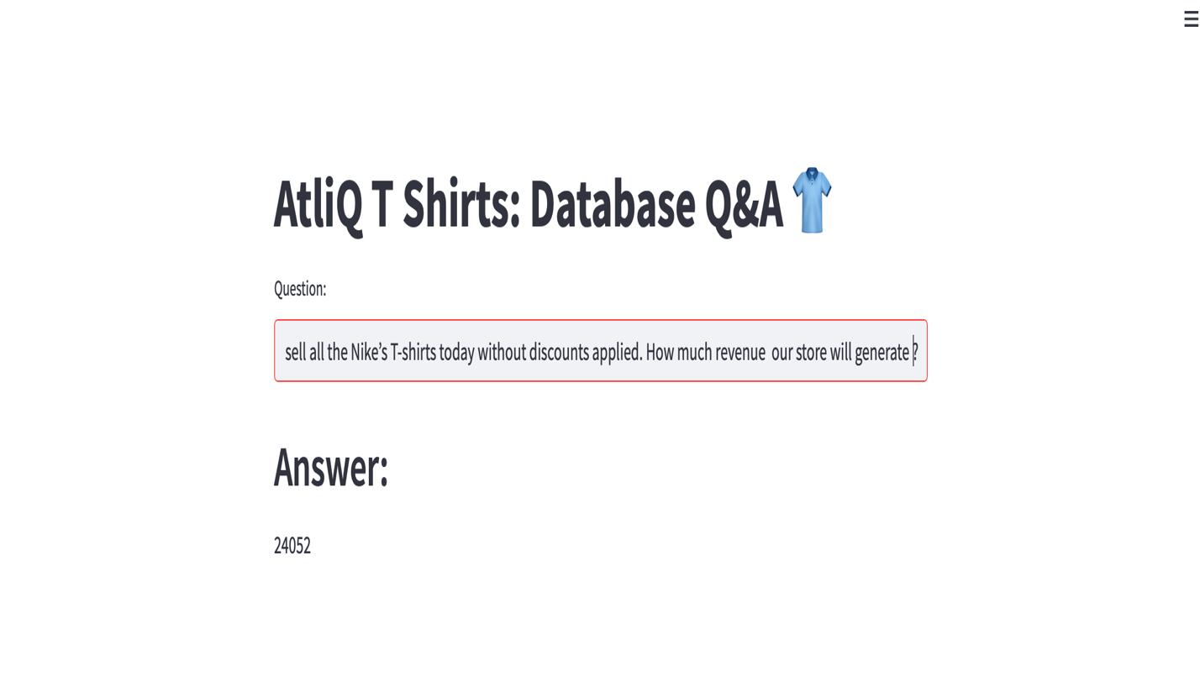

**Description:**

The main.py file is a Streamlit application for querying a database about t-shirt inventory. It prompts users for a question, uses a helper function get_few_shot_db_chain from langchain_helper.py to process the question, and then displays the answer. The application's title is "AtliQ T Shirts: Database Q&A".

The project utilizes Langchain to connect to a MySQL database containing information about t-shirt inventory. It involves creating a machine learning model to generate SQL queries based on natural language questions, leveraging GooglePalm and HuggingFace embeddings for language understanding. The langchain_helper.py script sets up the connection to the database, prepares the model, and defines how questions are transformed into SQL queries to fetch answers from the database. The Streamlit app in main.py provides a user interface for inputting questions and displaying answers.